Addition of two numbers in base p
Let and  be two integers represented in base.
=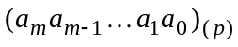, with m+1 digits and
B= 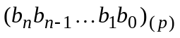, with n+1 digits.
We calculate 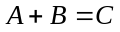 =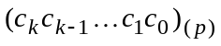, with k+1 digits.
The addition of two numbers is performed starting with the units digit (index 0), from right to left, the process being repetitive with a number of max(m,n)+1 iterations.
In each iteration i, the digits (after they have been converted to decimal) of the same index (i) from the two numbers and the carry digit (0 or 1) from the previous iteration (i-1) are added.
The resulting sum provides 2 digits:
- the carry digit used in the next iteration is the quotient obtained by dividing sum by p;
- the positionally corresponding digit (index i) in number C is the remainder obtained by dividing sum by p;
!!! All the operations presented above are performed in decimal.
An initial carry digit, 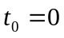, is considered. The number with less digits is filled with 0 digits (insignificant digits) to the left, to have max(m,n)+1 digits in both numbers. The addition operation is described by the following mathematical formulas:
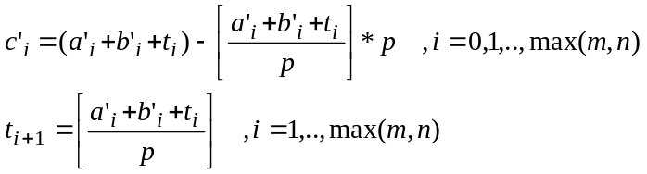,
- where: 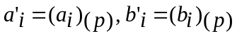(the digits of both numbers are converted to decimal)
- now all the digits in the formulas are decimal digits and the calculations are performed in
decimal
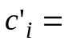 the remainder obtained by dividing 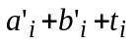 by
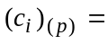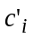 (the decimal digit 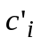 is converted in a digit of base )
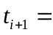 the quotient obtained by dividing 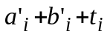 by
If 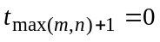 then 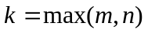,
else 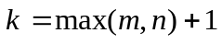 and 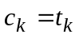(is 1, being the last carry digit)
Example 1: 43012₍₅₎ + 3243₍₅₎ =?₍₅₎
₁ ₁ ₀ ₁ ₁ ₀ m=4, n=3
43012₍₅₎ + i=0 : 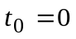 i=2 : 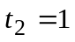
03243₍₅₎ 2₍₅₎ +3₍₅₎ +0₍₅₎= 2 +3 + 0 =5 0₍₅₎ +2₍₅₎ +1₍₅₎= 0 +2 + 1 =3
───── t₁ = [5/5]=1, 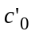=5-1*5=0 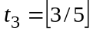=0, 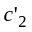=3-0*5=3
101310₍₅₎ 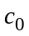 =0₍₅₎ 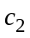=3₍₅₎
i=1 : 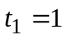 i=3 : 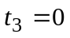
1₍₅₎ +4₍₅₎ +1₍₅₎= 1 +4 + 1 =6 3₍₅₎ +3₍₅₎ +0₍₅₎= 3 +3 + 0 =6
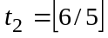=1, 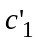=6-1*5=1 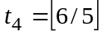=1, 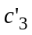=6-1*5=1
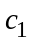=1₍₅₎ 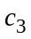 =1₍₅₎
i=4 : 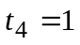
4₍₅₎ +0₍₅₎ +1₍₅₎= 4 + 0 + 1 =5
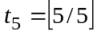=1, 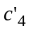= 5-1*5=0
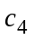= 0₍₅₎
k = 5, 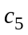=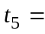1₍₅₎
43012₍₅₎ + 3243₍₅₎ =101310₍₅₎

Example 2: A5F₍₁₆₎ + 96BD₍₁₆₎ =?₍₁₆₎
₀ ₁ ₁ ₁ ₀ m=3, n=2
0A5F₍₁₆₎ + i=0 : i=2 :
96BD₍₁₆₎ F₍₁₆₎ +D₍₁₆₎ +0₍₁₆₎= 15 +13 +0 =28 A₍₁₆₎ +6₍₁₆₎ +1₍₁₆₎= 10 +6 + 1 =17
───── 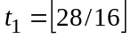=1, =28-1*16=12 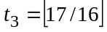=1, =17-16*1=1
A11C₍₁₆₎ 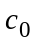=C₍₁₆₎ 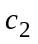=1₍₁₆₎
i=1 : i=3 :
5₍₁₆₎ +B₍₁₆₎ +1₍₁₆₎= 5 +11 + 1 =17 0₍₁₆₎ +9₍₁₆₎ +1₍₁₆₎= 0 +9 + 1 = 10
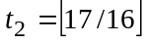=1, =17-16*1=1 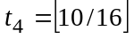=0, =10-0*16=10
=1₍₁₆₎ =A₍₁₆₎
k = 3, 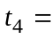0

A5F₍₁₆₎ + 96BD₍₁₆₎ =A11C₍₁₆₎

Example 3: 1110101101₍₂₎ + 110110011₍₂₎ = ?₍₂₎
₁ ₁ ₁ ₀ ₁ ₁ ₁ ₁ ₁ ₁ ₀
1110101101₍₂₎ +
0110110011₍₂₎
───────
10101100000₍₂₎

Multiplication of a number by a digit in base p
Let be a integer and b a digit, both written in base p:
=, with m+1 digits and 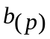.
We calculate the product: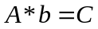 =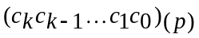, with k+1 digits.
The multiplication of a number by a digit is performed starting with the units digit (index 0), from right to left, the process being repetitive with a number of m+1 iterations.
At each iteration i, the current digit in A is multiplied by b, after they have been converted to decimal, and then the carry digit from the previous iteration (i-1) is added. The calculated value provides 2 digits:
- the carry digit used in the next iteration is the quotient obtained by dividing value by p;
- the positionally corresponding digit (index i) in C is the remainder obtained by dividing value by p.
!!! All the operations presented above are performed in decimal.
An initial carry digit, , is considered. The multiplication operation is described by the following mathematical formulas:
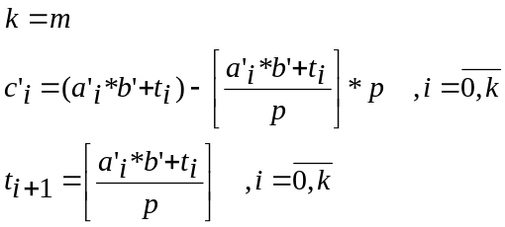
If 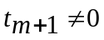 then 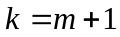.
- where: 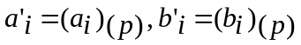( the digits of A and b are converted to decimal)
- the calculations in the above formulas are performed in base 10
- the quotient obtained by dividing 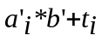 by ; 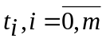 are decimal values
- 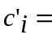 the remainder obtained by dividing by
(the decimal digit is converted to a digit of base )
The product C has m+2 digits if ,
else C has m+1 digits.
Example 1: 2031_{(4) *}3₍₄₎ =?₍₄₎
₁ ₀ ₂ ₀ ₀ m=3
2031₍₄₎ * i=0 : i=2 : 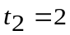
3₍₄₎ 1_{(4) *}3₍₄₎ +0₍₄₎= 1*3+ 0 = 3 0₍₄₎ *3₍₄₎ +2₍₄₎= 0*3+2 = 2
───── 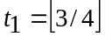= 0, =3-0*4=3 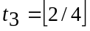=0, =2-0*4 =2
12213₍₄₎ =3₍₄₎ =2₍₄₎
i=1 : 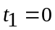 i=3 : 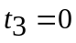
3₍₄₎ *3₍₄₎ +0₍₄₎= 3*3 +0 = 9 2₍₄₎ *3₍₄₎ +0₍₄₎= 2*3 +0 =6
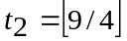=2, =9-2*4=1 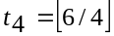=1, =6-1*4= 2
=1 ₍₄₎ =2₍₄₎
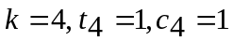

2031_{(4) *}3₍₄₎ =12213₍₄₎

Example 2: 2B5F_{(16) *}A₍₁₆₎ =?₍₁₆₎
₁ ₇ ₃ ₉ ₀ m=3
2B5F₍₁₆₎ * i=0 : i=2 : 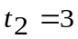
A₍₁₆₎ F_{(16) *}A₍₁₆₎ +0₍₁₆₎= 15*10+ 0 = 150 B₍₁₆₎ *A₍₁₆₎ +3₍₁₆₎= 11*10 +3 = 113
───── 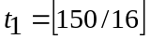= 9, =150-9*16=6 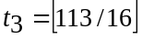=7, =113-7*16 =1
1B1B6₍₁₆₎ =6₍₁₆₎ =1₍₁₆₎
i=1 : 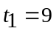 i=3 : 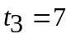
5₍₁₆₎ *A₍₁₆₎ +9₍₁₆₎= 5*10 +9 = 59 2₍₁₆₎ *A₍₁₆₎ +7₍₁₆₎= 2*10 +7 =27
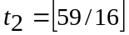=3, =59-16*3=11 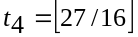=1, =27-1*16= 11
=B ₍₁₆₎ =B₍₁₆₎
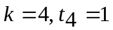
2B5F₍₁₆₎ *A₍₁₆₎ =1B1B6₍₁₆₎

Division of a number by a digit in base p
Let be a integer and b a digit, both written in base p:
=, with m+1 digits and .
We calculate C= the quotient obtained by dividing A by b, C=, with k+1 digits and the remainder r_{(p)}, 0<=r <b
The division is performed starting with the most significant digit (index m), from left to right, the process being repetitive with a number of m+1 iterations.
At each iteration i, a value obtained as the sum of the current digit (index i) in A with the product of the carry digit from the previous iteration i-1 and the base p, after all digits have been converted to decimal. The calculated value provides 2 digits:
- the carry digit used in the next iteration is the remainder obtained by dividing value by b;
- the positionally corresponding digit in C is the quotient obtained by dividing value by b;
The quotient C will have m+1 digits and if the most significant digit (index m) is 0 then it will be removed.
The carry digit obtained in the last iteration will represent the remainder r.

An initial carry digit, 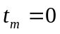, is considered. The division operation is formalized by the following mathematical formulas:
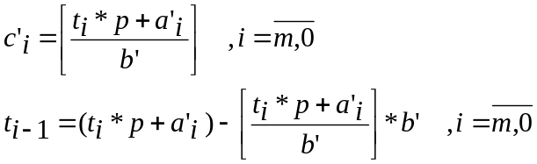
- where: 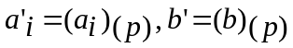(the digits of A and b are converted to decimal)
- the calculations in the above formulas are performed in base 10
- 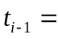 the remainder obtained by dividing 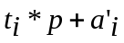 by ; 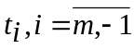are decimal values
- 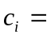 the quotient obtained by dividing by
(the decimal digit is converted to a digit of base )

- the remainder : 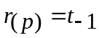
Example 1:
⁰A5B₍₁₆₎ | 8₍₁₆₎ m=2, 8₍₁₆₎=8
/ | 14B₍₁₆₎ – quotient: C i = 2 , 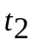=0, 0 *16+A₍₁₆₎ =0+10=10
²5 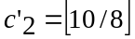=1, 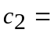1₍₁₆₎, =10-8*1=2,
/ i = 1 , =2, 2 *16+5₍₁₆₎ =2*16+5=37
⁵B 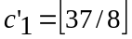=4, 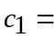4₍₁₆₎, 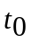=37-8*4=5
/ i = 0 , =5, 5 *16+B₍₁₆₎ =5*16+11=91
3₍₁₆₎ – remainder: r 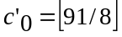=11, 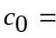B₍₁₆₎ 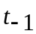=91-8*11=3
= 3 = 3₍₁₆₎= r

Example 2:
⁰2043₍₈₎ | 5₍₈₎ m=3, 5₍₈₎= 5
/ |0323₍₈₎ – quotient: C i = 3 , 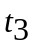=0, 0*8+2₍₈₎ =0+2=2
²5 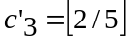=0, 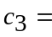0₍₈₎, =2-5*0=2,
/ i = 2 , =2, 2 *8+0₍₈₎ =2*8+0=16
¹4 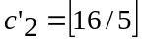=3, 3₍₈₎, =16-5*3=1
/ i = 1 , =1, 1 *8+4₍₈₎ =1*8+4= 12
²3 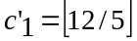=2, 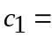2₍₈₎ = 12-5*2=2
/ i = 0 , =2, 2 *8+3₍₈₎ =2*8+3= 19
4₍₈₎ – remainder: r 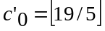=3, 3₍₈₎ = 19-5*3=4
= 4 = 4₍₈₎= r

Subtraction of two numbers in base p
Let and be two integers represented in base.
=, with m+1 digits and
B= , with n+1 digits., 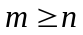
We calculate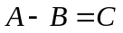 =, with k+1 digits.
A is the minuend, B the subtrahend and C the difference.
The subtraction of the two numbers is performed starting with the units digit (index 0), from right to left. If necessary, the number B will be filled to the left with m-n insignificant zeros.
Therefore, in the first iteration 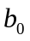 will be subtracted from 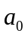. If 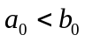, one unit will be borrowed from the higher order digit of A, which means (due to the positional writing of numbers) that the borrow is the value p of the base, and the expression 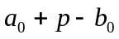 is calculated in decimal obtaining the digit 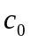. The borrow can be considered to be a carry digit that can take the value 0 or -1 in the case of a borrow.
In the next iterations we work similarly but we also add the carry from the previous iteration to the digit of A before subtracting the corresponding digit of B. The result has at most +1 digits.
An initial carry digit is considered. If necessary, B will be filled to the left with m-n insignificant zeros. The subtraction operation is formalized by the following mathematical formulas:
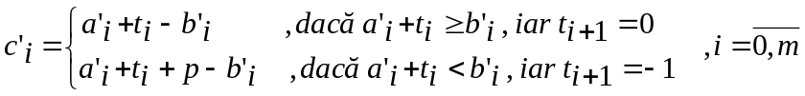
The leftmost insignificant zero digits of C will be eliminated. The number of digits will be calculated such as 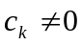 and 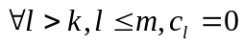.
- where: (the digits of A and B are converted to decimal )
- the calculations in the above formulas are performed in base 10
- (the decimal digit is converted to a digit of base)
Example 1: A11C₍₁₆₎ – A5F₍₁₆₎ =?₍₁₆₎
₋₁ ₋₁ ₋₁ ₀ m=3, n=2,
A11C₍₁₆₎ - i=0 :
0A5F₍₁₆₎ C₍₁₆₎ ₎+0₍₁₆₎ < F₍₁₆₎ => borrow one unit from position i+1=1, which becomes
───── 10₍₁₆₎ in the current position and 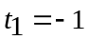
96BD₍₁₆₎ C₍₁₆₎ +0₍₁₆₎ + 10₍₁₆₎- F₍₁₆₎ =(conversion to decimal)= 12+16-15= 13 = 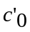
= D₍₁₆₎
i=1 : 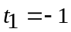
1₍₁₆₎+(-1)₍₁₆₎ < 5₍₁₆₎ => borrow => 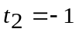
1₍₁₆₎ +(-1)₍₁₆₎ + 10₍₁₆₎- 5₍₁₆₎ = 1-1+16-5= 11 = 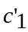
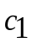= B₍₁₆₎
i=2 : 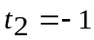
1₍₁₆₎ ₊(-1)₍₁₆₎ < A₍₁₆₎ => borrow => 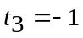
1₍₁₆₎ +(-1)₍₁₆₎ + 10₍₁₆₎- A₍₁₆₎ = 1-1+16-10= 6 = 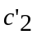
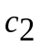= 6₍₁₆₎
i=3 : 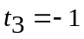
A₍₁₆₎ +(-1)₍₁₆₎ > 0₍₁₆₎
A₍₁₆₎ +(-1)₍₁₆₎ - 0₍₁₆₎ = 10-1-0= 9 = 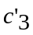
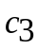= 9₍₁₆₎

Example 2: 20053₍₆₎ – 4444₍₆₎ =?₍₆₎
₋₁ ₋₁ ₀ ₋₁ ₀ m=4, n=3,
20053₍₆₎ - i=0 :
04444₍₆₎ 3₍₆₎ ₎+0₍₆₎ < 4₍₆₎ => borrow one unit from position i+1=1, which becomes
───── 10₍₆₎ in the current position and
11205₍₆₎ 3₍₆₎ +0₍₆₎ + 10₍₆₎- 4₍₆₎ =(conversie în zecimal)= 3+6-4= 5 =
= 5₍₆₎
i=1 :
5₍₆₎+(-1)₍₆₎ ≥ 4₍₆₎ => 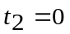
5₍₆₎ +(-1)₍₆₎ - 4₍₆₎ = 5-1-4= 0 =
= 0₍₆₎
i=2 : 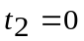
0₍₆₎ ₊0₍₆₎ < 4₍₆₎ => borrow =>
0₍₆₎ +0₍₆₎ + 10₍₆₎- 4₍₆₎ = 6-4= 2 =
= 2₍₆₎
i=3 :
0₍₆₎ +(-1)₍₆₎ < 4₍₆₎ => borrow => 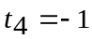
0₍₆₎ +(-1)₍₆₎ + 10₍₆₎- 4₍₆₎ = -1+6-4= 1 =
= 1₍₆₎
i=4 : 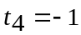
2₍₆₎ +(-1)₍₆₎ > 0₍₆₎
2₍₆₎ +(-1)₍₆₎ - 0₍₆₎ = 2-1=1 =
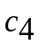=1₍₆₎
Example 3: 110001011000₍₂₎ - 1110110011₍₂₎ =?₍₂₎
0 -1 -1 -1 0 -1 0 0 -1 -1 -1 0
110001011000₍₂₎ -
001110110011₍₂₎
────────────
100010100101₍₂₎

